MINI-STATIC
12/1/2023
NEWS
Lunch Bunch is the first Thursday of the month, Hill Road Grille, 2161 W Hill Rd Flint, MI 48507. On December 7th at 11:30 AM, just be there!
In person meeting will be not be held in December.

MEMBERSHIP DUES For 2024 are due by December 31, 2023!
Go to W8ACW.org for mail in application or paypal!
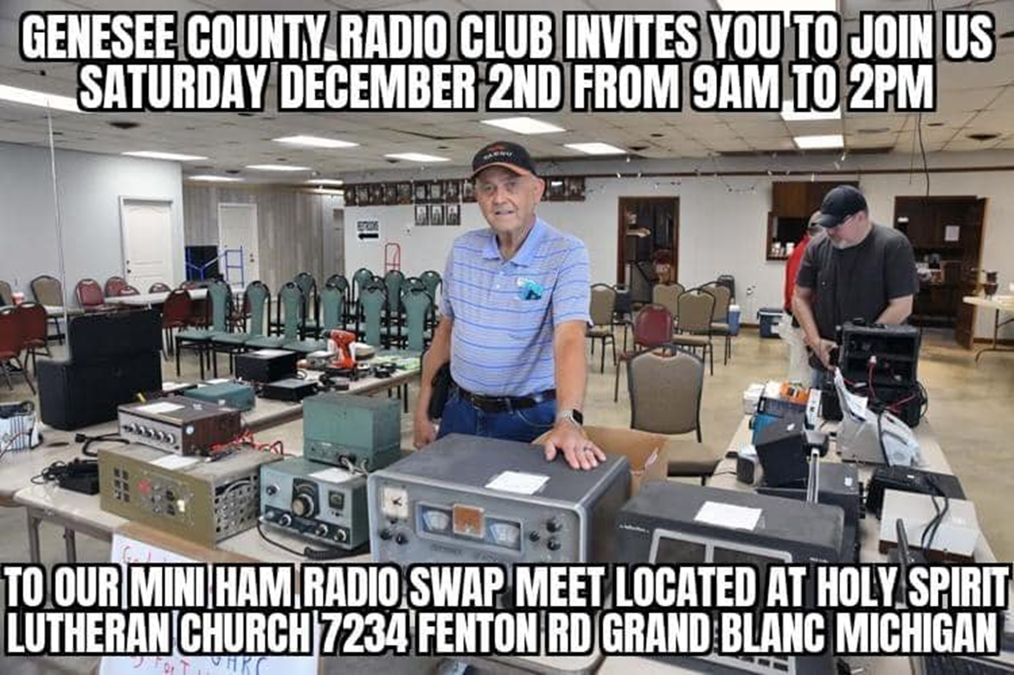

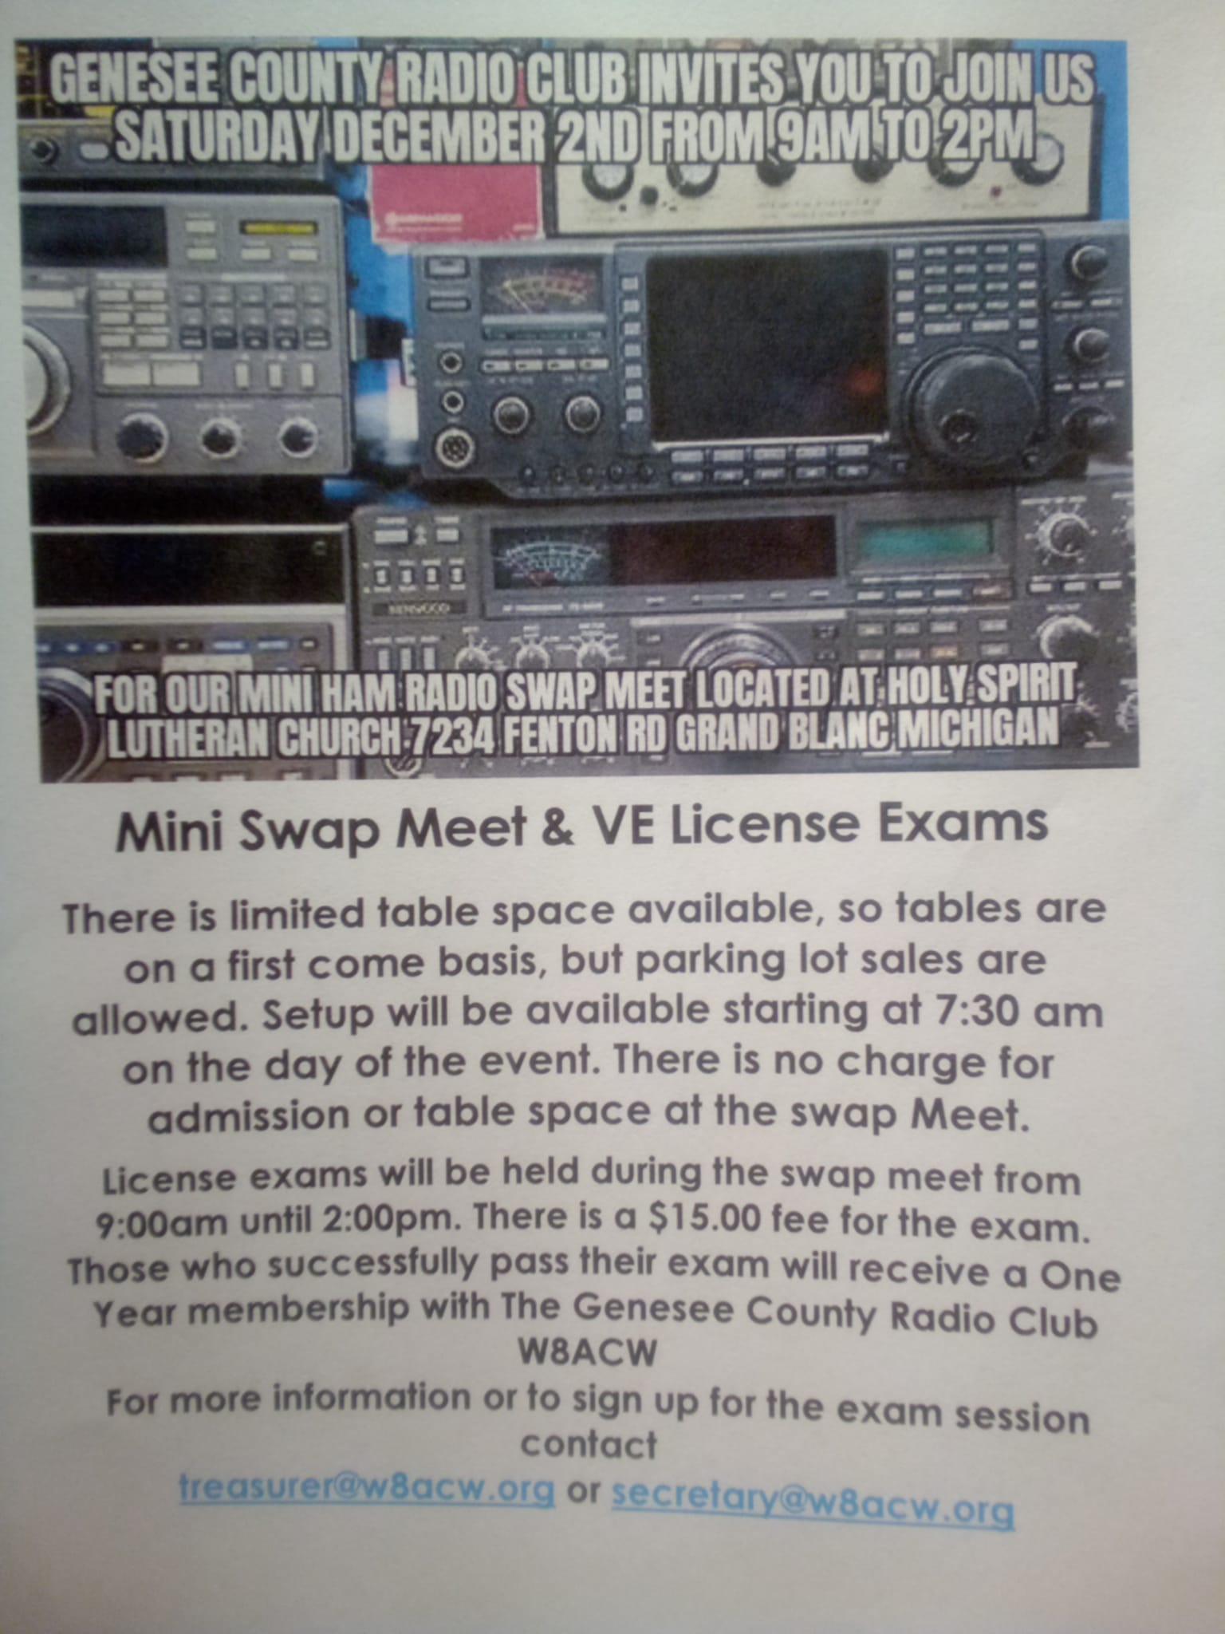
Welcome New Members
Bruce Easton KE8ZMQ

Thursday Night Net
The net begins each Thursday evening at 2000 and is a directed net. One of our members serves as the Net Control Station.
We talk about the club and everything else related to Amateur Radio so be sure to check us out on the 2 meter repeater:
147.340Mhz + (100hz PL tone) or
on the 70cm repeater
444.200Mhz+ (107.2 PL tone)
The repeaters are linked for this net. All licensed amateurs are welcome.
Sign up to be a Net Control Operator at https://w8acw.org/home/net-information/
November 2023 GCRC Thursday Nets
No info
No one takes over Net Control!
ECHOLINK will be available on the repeater soon watch for an announcement!

.

General Membership Meeting Minutes

November 21st, 2023
The meeting was called to order at 7:00 pm by President Jerry Baker. A roll call of officers was called and those in attendance were, Jerry Baker - President, Gregory Kensbock - Secretary, and Mark Oliver – Member at Large, Treasurer Roberta Vasilow was excused.

There were 10 members present for the meeting, The Treasures report was given by the secretary who reported that we have a balance of $5,111.38 on deposit.

Committee Reports.
Jeff Kelly of the Nomination Committee was present but had no report.

New Business,
Nominations for the 2024 Board was called for, and there were only seven (7) ballots turned in, all were for the current Board members. So, by acclamation they will continue to hold their office for the 2024 Board. There were two write ins for members at large but they are appointed positions, next was a discussion concerning the upgrading of our repeaters, Jeff Kelly & Jeff Parker are going to install our new router so that we will be up to date with the latest technology. The President spoke on the upcoming Swap meet and asked for volunteers to help with the set up for the event. A report that all the testing materials for the VE License exams have been received.

Show and tell,
Al Smith gave a very informative talk on a 50-watt amplifier that he built. And the work and cost to do such along with where to obtain the parts to build it.

Around the room,
Was held and there was no perinate info for discussion, so the meeting was called to close at 7:25pm

